**DAILY ONLINE ACTIVITIES SUMMARY**

|  |  |  |  |  |  |  |  |  |
| --- | --- | --- | --- | --- | --- | --- | --- | --- |
| **Date:** | **09-07-2020** | | | | | **Name:** | **Kanaka BS** | |
| **Sem & Sec** | **6th & A** | | | | | **USN:** | **4al17cs039** | |
| **Online Test Summary** | | | | | | | | |
| **Subject** | | **-** | | | | | | |
| **Max. Marks** | | **-** | | **Score** | | | **-** | |
| **Certification Course Summary** | | | | | | | | |
| **Course** | **System Software and Compiler Design** | | | | | | | |
| **Certificate Provider** | | | **-** | | **Duration** | | | **1.5hours** |
| **Coding Challenges** | | | | | | | | |
| **Problem Statement:**  **Python Program for Find largest prime factor of a number** | | | | | | | | |
| **Status: Solved** | | | | | | | | |
| **Uploaded the report in Github** | | | | | **yes** | | | |
| **If yes Repository name** | | | | | <https://github.com/kanakabs/Daily-Status> | | | |
| **Uploaded the report in slack** | | | | | **yes** | | | |

**ONLINE COURSE**

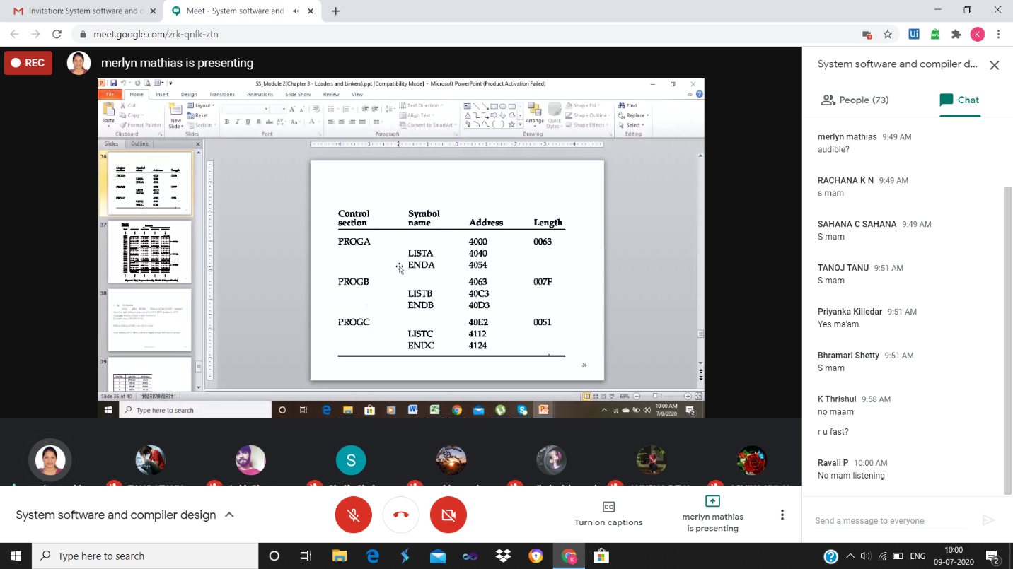

**ONLINE CODING**

**Python Program for Find largest prime factor of a number**

def Largest_Prime_Factor(n):

prime_factor = 1

i = 2

while i <= n / i:

if n % i == 0:

prime_factor = i

n /= i

else:

i += 1

if prime_factor < n:

prime_factor = n

return prime_factor

print(Largest_Prime_Factor(420))

